I will display the credit card data for two countries. Making comparison between India and Austria’s credit card usage by gender. Which gender is using the credit card on what purchase.

The visualization below is a Tableau screenshot of Australia Data analysis.

The analysis bar graph shows what card type by gender is used for what types of purchase.

It shows that in Australia, both male and female used the most money on entertainment and leased monies/credit card on party sullies such as napkins, plates, etc. It also shows that the fuel consumption is very low. It looks like those females in Australia spend more monies on Entertainment then male. But both gender has a high expense associated with Entertainment. It also shows that both genders devote an equal amount of funds to vitamins. But, the female populations tend to spend more money on travel as opposed to the male gender. It also shows that both gender used the “Gold” card more then that other cards. When compare to Inida, Platium card(s) were more used by Austurian then Indian.

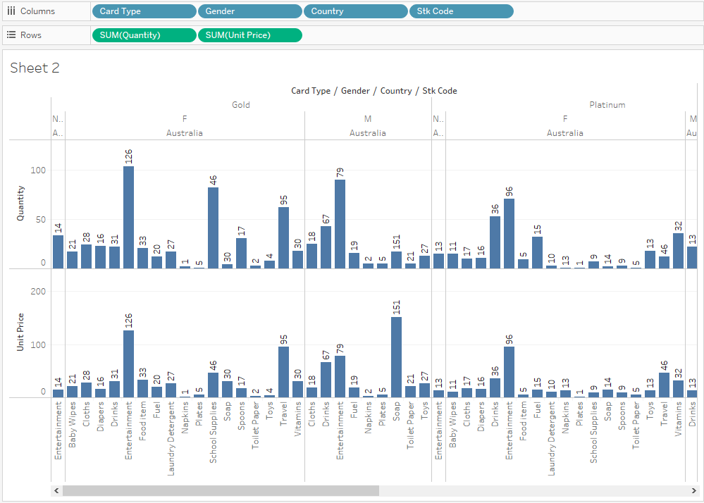

Figure 1

The Visualization below shows the package bubble with labels. It shows the same information as above, but just a different visualization.

By dragging the same dimensions and measurements for this visualization, I can pull up the same data. Additionally, I added Labels and details to the bubble so, when the user hovers over the bubbles, it will provide the details information on each bubble as shown in figure 3 and 4. 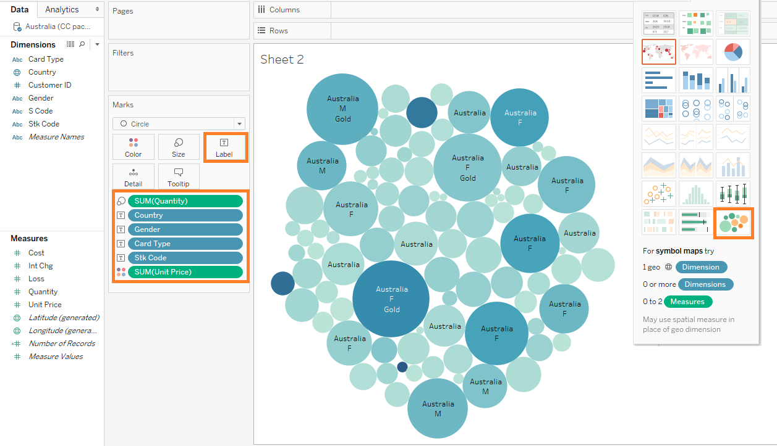

Figure 2

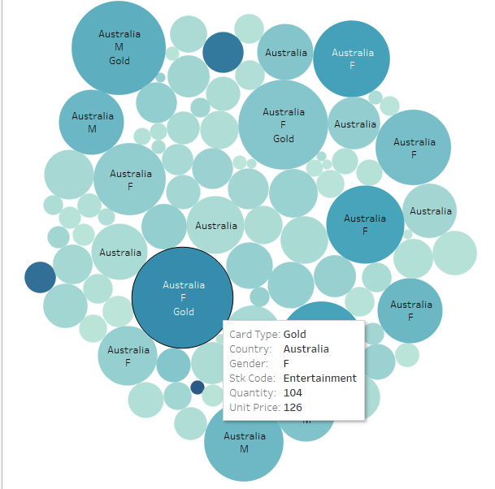

Figure 3

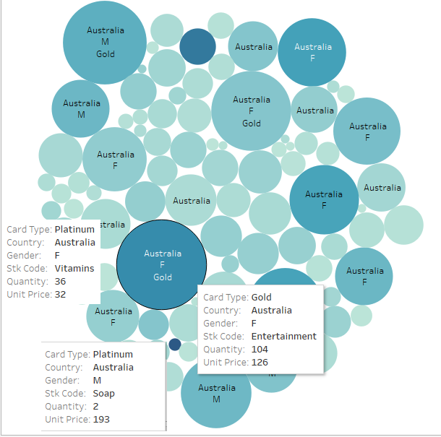

Figure 4

Figure 5 below shows purchased by all credit type by gender where country type is “Australia” Figure 5 shows clearly by looking at Stk Codes on what items the credit cards were used most by Male and Female. It also shows that the Signature card was not utilized a lot by the Australian. 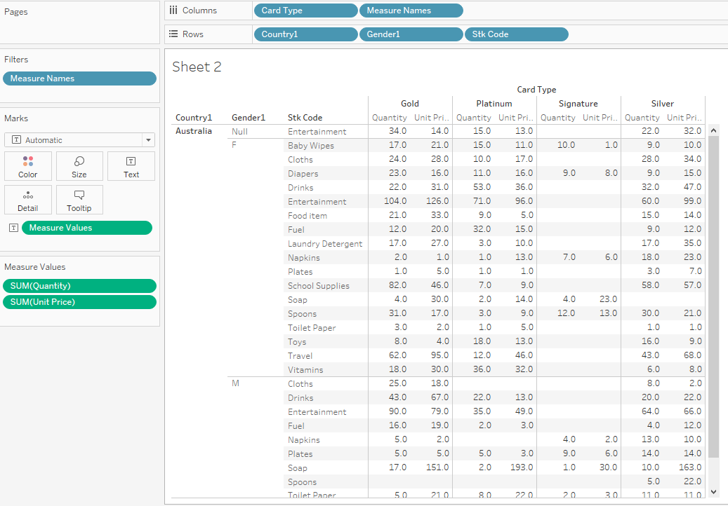

Figure 5

Figure 6 shows similar data for India as shown above in figure 1 for Australia.

The Figure 6 shows that the “Gold” credit card was utilized the most for Daycare and Travel by Females. Male used the gold card mostly for Entertainment. The female population incurred the majority of the sales. More credit card shopping was done by female than male. It also shows that Signature card was not used too often by either male or female. 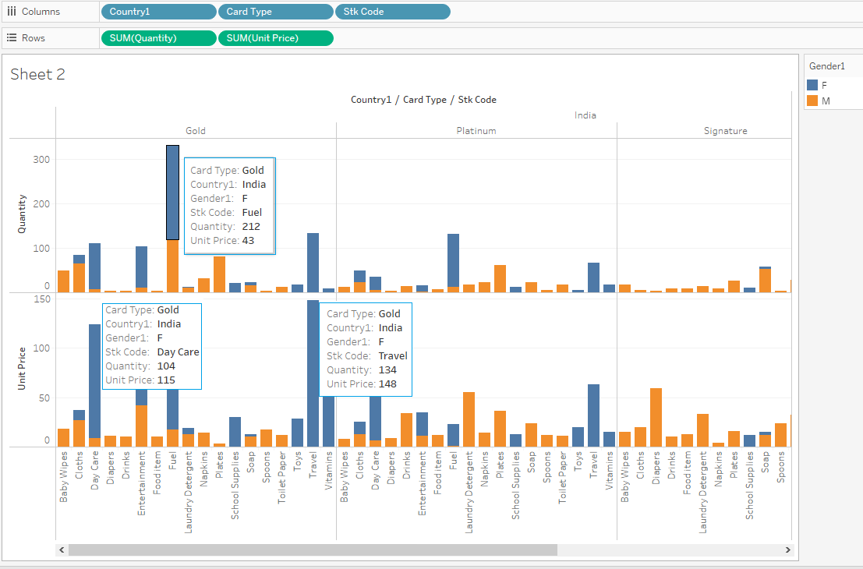

Figure 6

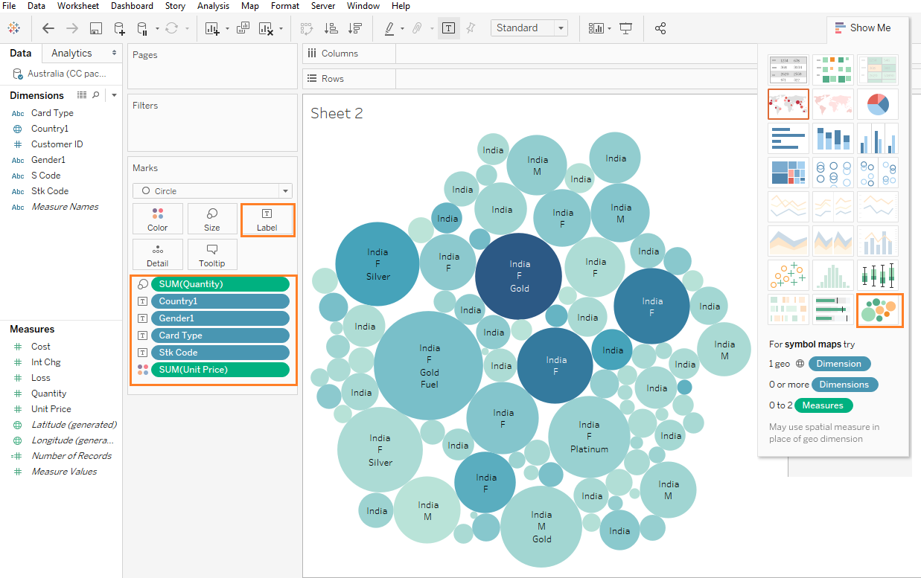

Figure 7

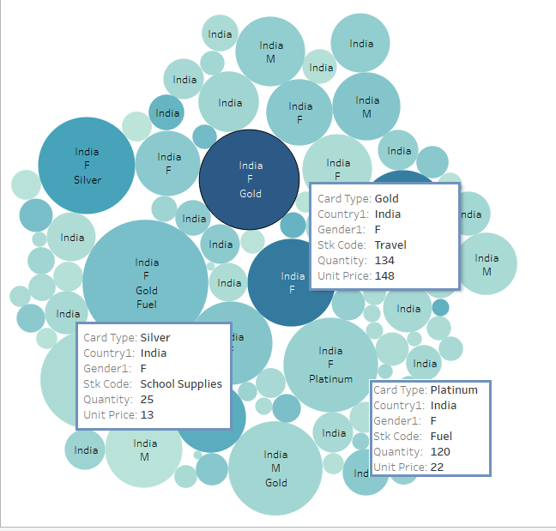

Figure 8

Figure 9 below shows purchased by all credit type by gender where country type is “India” Figure 9 shows clearly by looking at Stk Codes on what items the credit cards were used most by Male and Female. It also shows that the Signature card was not utilized as much as the other cards by India. Toys were mainly purchased using Signature and Silver credit card. 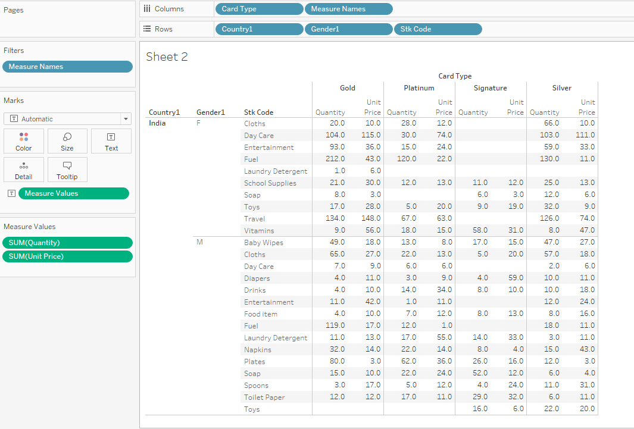Figure 9